How to install and activate your personal copy of MATLAB (Student Copy)

MathWorks Account Creation
- Go to http://www.mathworks.com
- Create a new MathWorks account
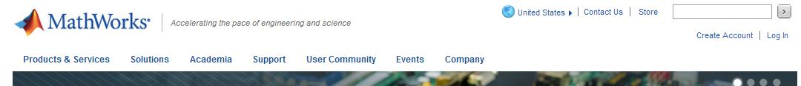
- You should use your university email (unife.it) and select the option “Academic use”

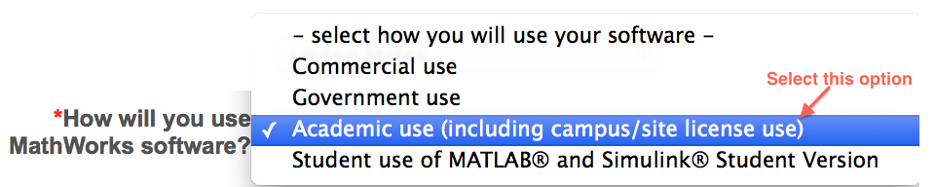

Associate with the license
- As soon as you are logged in your MathWorks account click on “Manage Licenses” and then on the button “Add License”:
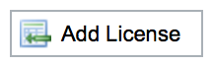
- Select “Activation Key” and click Continue
- Enter the Activation Key:
- 38126-92284-76765-40650-43058
and click Continue.

Download the products
- On your account page you can click on “Get Licensed Product and Updates” to download the installation files.

Install
- Select the option: “Install automatically using the Internet”
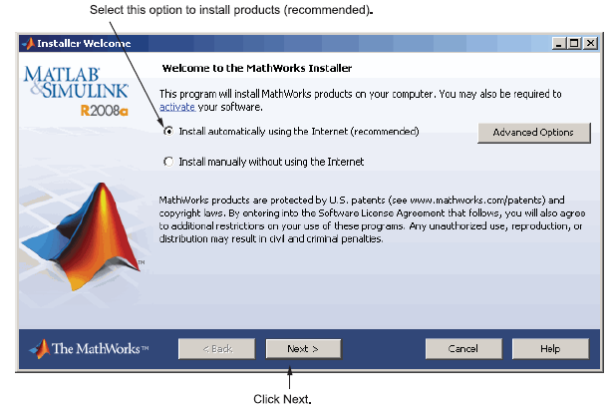
- Review the License Agreement and click next.
- Login to your MathWorks Account
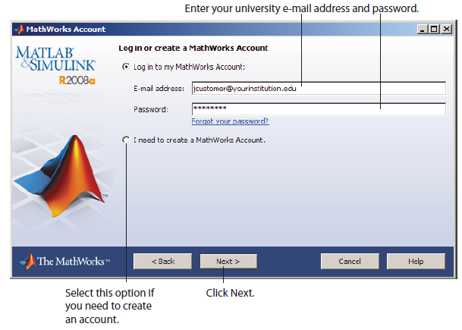
- Select the license … and click “Next”.
- Select the Typical installation, specify your installation folder and start the installation procedure.
Activate
- At the end of the installation process proceed with activation.
- Select license … and Click “Next”
- Enter your Activation Key:
- 38126-92284-76765-40650-43058
And click “Next”
- Specify the user name that you use to login into your PC.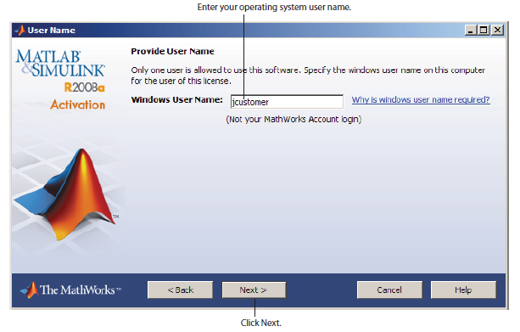
- Click Next and then Activate.
If you need installation help please open a Service Request by clicking on “Create new Request” on your MathWorks Account. Fill in a Technical Support -> Installation request to receive direct assistance by MathWorks Installation Support Team.

ADDITIONAL RESOURCES:
- Online Documentation:
http://www.mathworks.com/help/
- MATLAB Answers:
http://www.mathworks.com/matlabcentral/answers/
- TAH Resource Kit:
http://www.mathworks.com/academia/tah-support-program/campus.html

